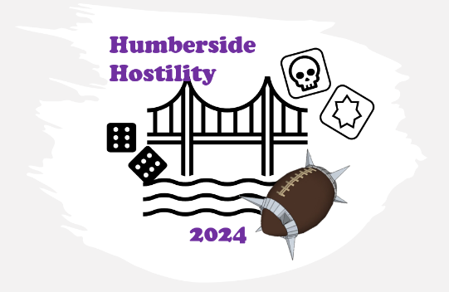
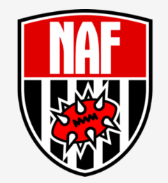

Almost a year has past since you settled your many beefs. Yeah, you took a few knocks and stinky Joe don't walk quite right anymore but you showed ‘em....or so you thought.
Rumours are starting, and so it looks like you will have to show them all who was right....again...and this time its persona!!

Once again every game is a chance to put to bed “that” grudge which keeps you and your players up at night.

Overview:
A resurrection 7s tournament kindly being hosted at the Hulls Angels Club in the Hull City Centre.
All rules from the Deathzone rule book for 7s play.
5 Games (1 hr 15 min per game)
Random 1st game draw, then Swiss pairing after that.
18 coaches Max
Tickets can be purchased from the Venues website, https://hullsangels.com/event/humberside-hostility-2/ , please ensure you provide your name and NAF details when buying your entry.

Roster Creation:
Each team has a budget of 600 GP
7-11 players (max 4 positional players, and no more than 2 of any one of them).
No purchased re-rolls during roster building.
No star players – they are all too self-absorbed to settle any beef with the likes of us – they would just pay someone else to do it (maybe they have).
Inducements from page 93 of the DZ rule book – with the exception of no Desperate Measures, Special Plays or Mercenaries.

Skills:
Each team nominates a “captain” and they get “Leader” as a free skill before assigning skills package.
Starting skills Package:
Tier 1 - Amazons, Chaos Dwarf, Dark Elf, Dwarf, Lizardmen, Norse, Undead, Skaven, Underworld Alliance, High Elves, Wood Elves.
1 primary skill
Tier 2- Black Orcs, Chaos Chosen, Chaos Renegades, Elven Union, Humans, Nobility, Khorne, Necromantic Horror, Nurgle, Orcs, Old World Alliance, Tomb Kings, Vampires, Slann.
1 primary, 1 secondary skill (can be exchanged for primary)
Tier 3- Goblins, Halflings, Ogres, Snotlings
2 primary, 2 secondary skills (can be exchanged for primary)
Send completed rosters through to humberside.hostilitybb@yahoo.com no later than 14th October 2023.

Special rules:
Skill Escalation: End of rounds 1-4, one random player (inc captain), gets 1 random primary skill to keep for the rest of the tournament (rolled for by opponent).
Weather: All games will roll on the “coastal weather table” (because its Hull)
FEUD!: Each game will use a version of the “Feud!” Game event from the start.
• During set up each game, One random player on each team have beef with each other. When they block or blitz each other they get +2 strength and mighty blow +1.
• The feud is “settled” once one of these players is knocked out or better. The victorious coach gets the bonus points and adds 1 to their “feuds settled” tally.
• A feud can be settled with a Foul, so long as the fouling player is the one with the Feud.
• A feud cannot be settled with a “Both Down” that results in both players being KO or better – neither player is conscious enough to remember winning that scrap and so the feud remains unsettled.
Points:
Standard Points | Bonus Points
Win – 3 pts | Touchdowns (score 3 TDs) – 1pt
Draw – 1 pt | Casualties (cause 3 casualties) – 1 pt
Loss – 0 pts | Clean Sheet (concede no Touchdowns) – 1 pt
 | Settle Feud – 2pts

Order of events:
9.00 - 9.30 registration and announcements
9.30-10.45 Game 1
15 min break
11.00-12.15 Game 2
1 hr lunch
1.15-2.30 Game 3
15 min break
2.45-4.00 Game 4
15 min break
4.15-5.30 Game 5
15 min Break
5.45-6.00 wrap up and awards.

